MLflow Model Tracking & Management

Project: Iris Classification Pipeline

1. Workflow Overview
The objective of this project was to implement a full machine learning lifecycle using MLflow. The workflow follows these automated steps:

Environment Setup: Initializing an MLflow experiment named Iris_Classification_Experiment.

Data Preprocessing: Loading the Iris dataset and performing an 80/20 train-test split.

Model Training: Training both Logistic Regression and Random Forest classifiers.

Tracking: Logging hyperparameters (C, n_estimators, max_depth) and performance metrics (Accuracy, F1-Score, Precision).

Visualization: Generating and logging a Confusion Matrix and a Model Comparison bar chart as artifacts.

Model Management: Serializing the model as a .pkl file and registering it in the MLflow Model Registry.

Inference Safety: Implementing a payload validation function to check data integrity before prediction.

Task 1: Experiment Setup

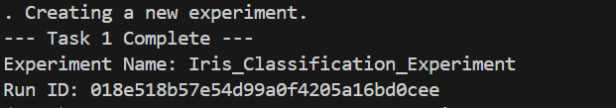
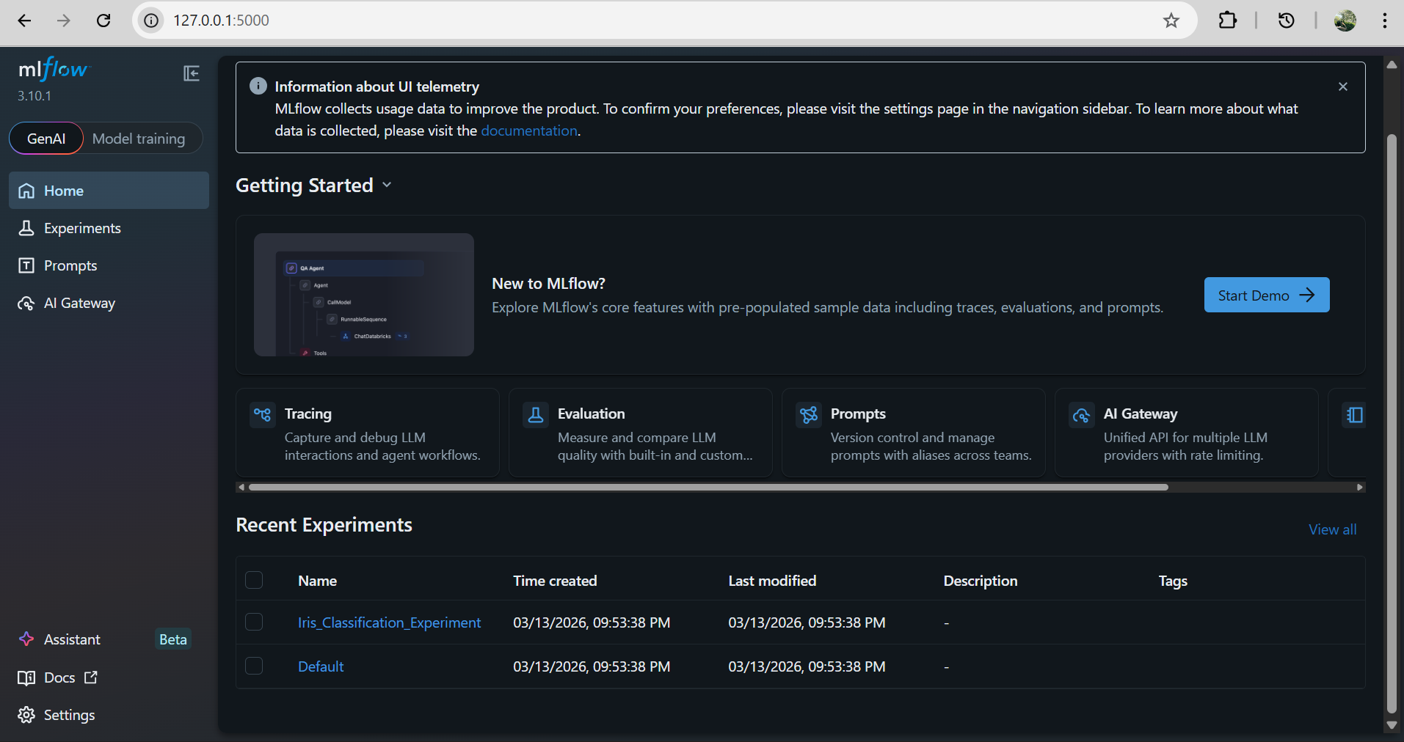

Task 2 : Training Two ML Models

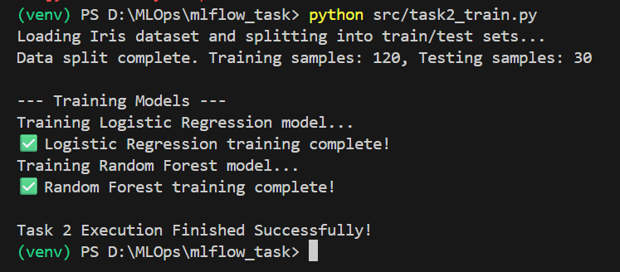

Task 3: Parameters and Metrics

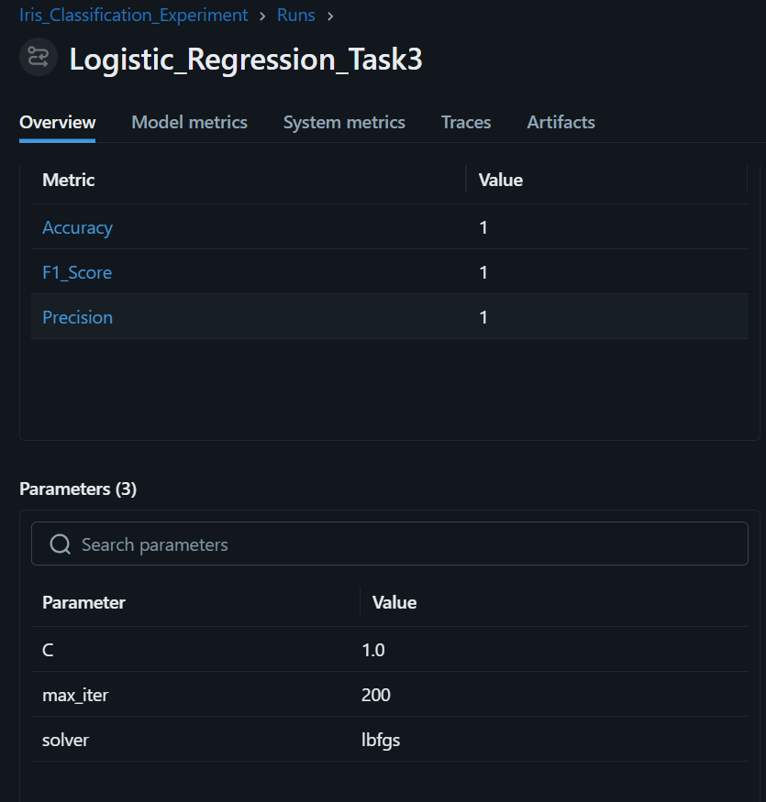
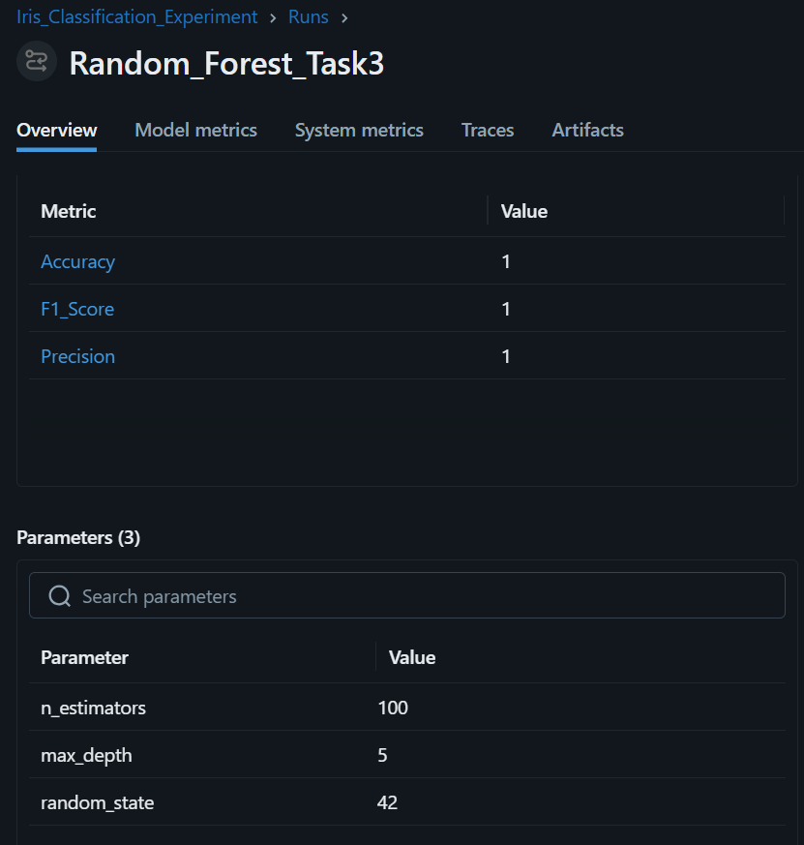

Task 4 & 5: Artifacts and Model Logging

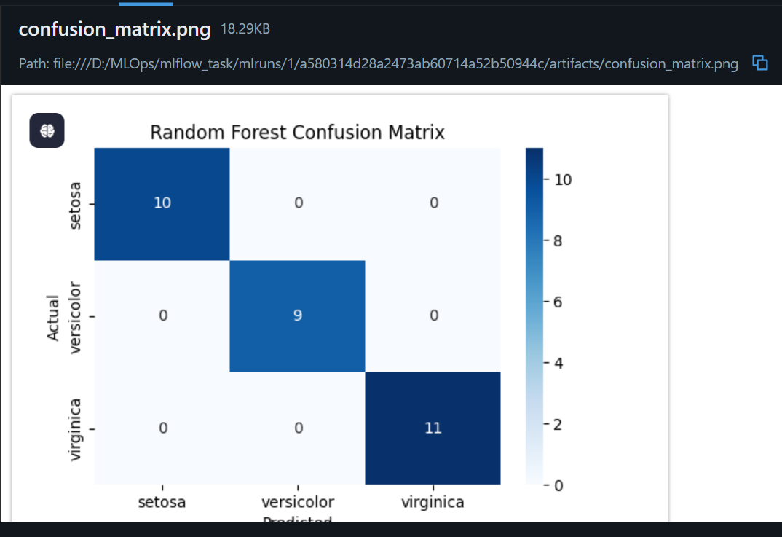

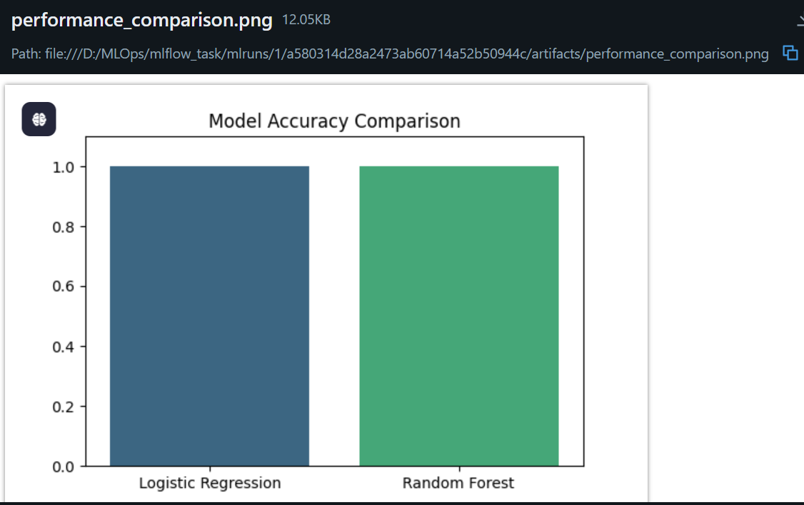

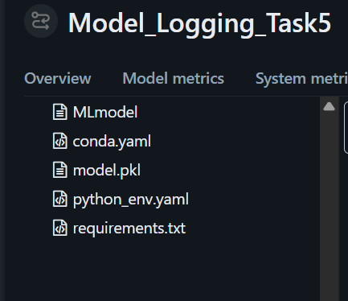

Task 6: Payload Validation

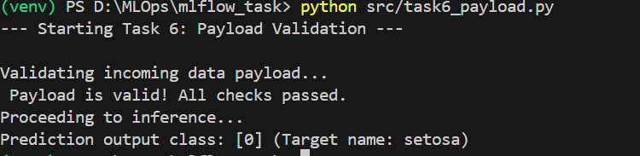

Task 7: Model Registration

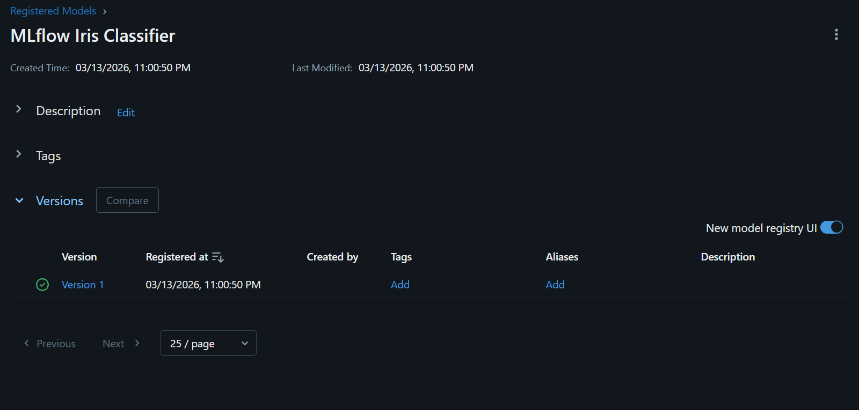

Task 8: Performance Comparison & Analysis

Model | Accuracy | F1-Score | Precision
Logistic Regression | 1.0 | 1.0 | 1.0
Random Forest | 1.0 | 1.0 | 1.0

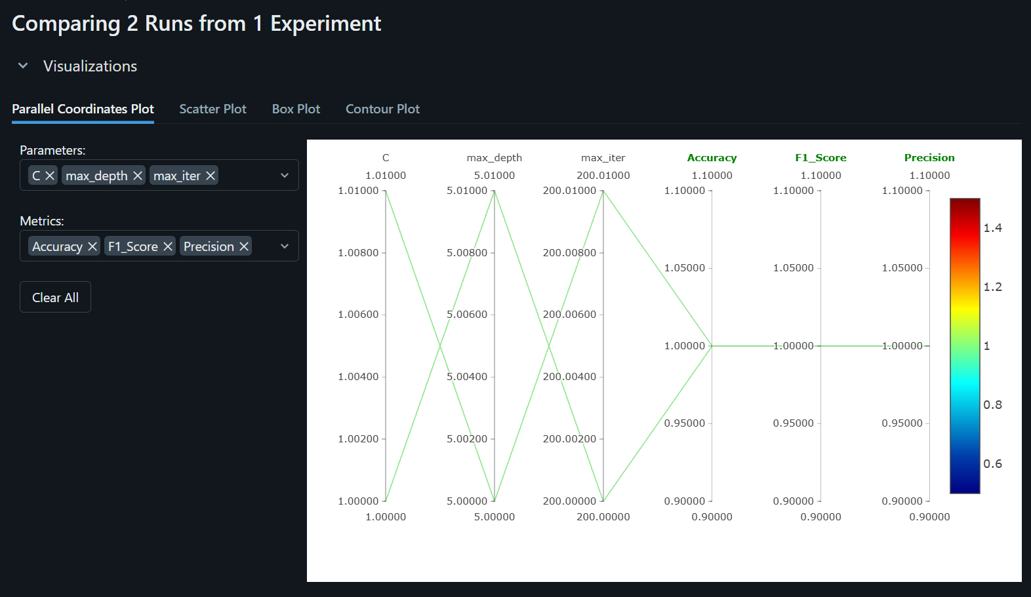

Which model performed better?
Both models achieved a perfect accuracy of 1.0. This is attributed to the clean, linearly separable nature of the Iris dataset and the controlled random_state.

What metric determined the best model?
The models were evaluated based on Accuracy, Macro F1-Score, and Precision. Since all metrics were identical, both models are considered equally optimal for this specific dataset..

